2012 Union Bears Roster
Jersey | Player | Position | Year
1 | Ty Dean | OF | Sr.
2 | Logan Dishner | C | Sr.
3 | Steven Lane | OF | Sr.
4 | Austin Baker | OF | Jr.
6 | Wes Hubbard | OF | Sr.
7 | Derrick Watkins | P | Jr.
9 | Tanner Clark | OF | Sr.
10 | Nathan Baker | SS/OF/P | Sr.
11 | Ben Baugh | 3B | Jr.
13 | Codi Collins | 1B/P | Sr.
14 | Ethan Villiard | OF | Fr.
15 | Wyatt Hamilton | 2B | Sr.
18 | Grant Bloomer | OF/1B | So.
20 | Daniel Fawbush | 1B | Sr.
21 | Hunter Neece | 1B/P | So.
22 | Jake Huff | SS/P | Sr.
23 | Tyler Smith | OF | Sr.
26 | Jessee Hagan | OF | Sr.
Varsity Head Coach: |  | J.W. Salyers
Varsity Asst. Coach: |  | David Wyrick
Varsity Asst. Coach: |  | David Gregory
Varsity Asst. Coach: |  | Todd Giles

2012 Final Statistics
Overall Record: 18-8
Hitting Stats
Hitter | PA | AB | R | H | XBH | RBI | BB | SO | SB | OBP | AVG | BA/RSP
Hamiton | 99 | 76 | 21 | 29 | 7 | 19 | 18 | 7 | 12 | .495 | .382 | .407
Dishner | 100 | 82 | 17 | 27 | 8 | 15 | 14 | 12 | 2 | .423 | .329 | .267
Villiard | 77 | 69 | 11 | 22 | 7 | 20 | 7 | 22 | 6 | .377 | .319 | .400
Huff | 102 | 72 | 28 | 23 | 6 | 9 | 27 | 14 | 13 | .500 | .319 | .353
N. Baker | 90 | 63 | 13 | 17 | 4 | 14 | 26 | 21 | 10 | .483 | .270 | .269
Clark | 40 | 30 | 9 | 8 | 1 | 5 | 8 | 12 | 12 | .421 | .267 | .231
Smith | 12 | 12 | 5 | 3 | 0 | 2 | 0 | 3 | 2 | .250 | .250 | .143
Fawbush | 94 | 78 | 11 | 19 | 5 | 17 | 15 | 15 | 2 | .362 | .244 | .231
Baugh | 79 | 55 | 14 | 13 | 2 | 12 | 17 | 17 | 12 | .400 | .236 | .381
Hubbard | 84 | 72 | 16 | 17 | 5 | 10 | 10 | 23 | 7 | .325 | .236 | .125
Lane | 51 | 42 | 3 | 9 | 2 | 10 | 7 | 10 | 1 | .314 | .214 | .217
Collins | 13 | 12 | 1 | 2 | 1 | 0 | 1 | 2 | 0 | .231 | .167 | .000
A. Baker | 14 | 9 | 9 | 1 | 0 | 0 | 4 | 6 | 10 | .385 | .111 | .000
Neece | 1 | 1 | 0 | 0 | 0 | 0 | 0 | 0 | 0 | .000 | .000 | .000
Dean | 2 | 1 | 3 | 0 | 0 | 0 | 1 | 1 | 0 | .500 | .000 | .000
TOTALS | 858 | 674 | 161 | 190 | 48 | 133 | 155 | 165 | 89 | .411 | .282 | .273
Pitching Stats
Pitcher | W | L | S | IP | ERA | K | H | BB
Huff | 8 | 2 | 1 | 56 | 1.25 | 43 | 49 | 21
A. Baker | 0 | 1 | 0 | 7.2 | 1.83 | 5 | 5 | 12
N. Baker | 6 | 2 | 1 | 63.2 | 2.20 | 106 | 38 | 61
Neece | 1 | 0 | 0 | 7.2 | 3.65 | 6 | 6 | 5
Collins | 3 | 1 | 0 | 26.1 | 4.25 | 17 | 23 | 26
Watkins | 0 | 0 | 0 | 2.2 | 5.25 | 2 | 7 | 2
Lane | 0 | 1 | 0 | 8 | 7.00 | 4 | 11 | 6
Baugh | 0 | 0 | 0 | 0.2 | 10.50 | 1 | 1 | 3
Lunsford | 0 | 1 | 0 | 2.2 | 13.12 | 0 | 4 | 2
Hubbard | 0 | 0 | 0 | 0.2 | 31.50 | 0 | 0 | 4
Clark | 0 | 0 | 0 | 0 | INF | 0 | 1 | 1
TOTALS | 18 | 8 | 2 | 176 | 2.82 | 184 | 145 | 143

2012 Schedule and Results
Opponent | Location | Result
Gate City | Away | L
Eastside | Home | W
Thomas Walker | Home | W
Sullivan North | Home | W
Gate City | Home | W
Happy Valley | TN High | L
Bourbon Co., KY | TN High | W
TN High | TN High | L
Sullivan East | Sullivan East | L
Central | Home | W
Clintwood | Away | W
JI Burton | Home | W
Central | Away | W
Honaker | Home | L
Sullivan North | Away | W
Clintwood | Home | W
Eastside | Away | W
JI Burton | Away | W
Letcher Co., KY | Home | W
Honaker | Away | W
Clintwood – LPD Tournament | UVA-Wise | W
Central – LPD Tournament | UVA-Wise | L
Central – Region D Tournament | Home | W
Gate City – Region D Tournament | Honaker | W
John Battle – Region D Tournament | Honaker | L
Chilhowie – VHSL Quarterfinals | Chilhowie | L
Totals |  | 18-8
LPD Champions (6-0)
LPD Tournament Runner-up
Region D Runner-up
VHSL Quarterfinals – Chilhowie 8 – Union 7 | Chilhowie
2012 was the first season of Union Bears Baseball. Wise County Schools consolidated to three schools after the 2010-2011 school year. Appalachia High School and Powell Valley High School merged to form Union High School.
Union Baseball enjoyed a highly successful baseball season. The 2012 Bears finished 18-8 overall while going undefeated in district play (6-0). The accomplishments of this team were a direct result of hard work during the off season. Twelve seniors played their last games this season. Highlights during the season included the first victory in Union Baseball history over Eastside on March 20, 2012. The final score was 9-0. The 2012 Bears defeated Gate City in the Region D semifinals by a score of 8-4 to earn a berth in the state playoffs. The season came to an end with a tough loss at Chilhowie while losing 7-6 in 8 innings. The seniors on the 2012 will be missed for years to come. The program has enjoyed your hard work over the past 4 years.
Personal achievements from this team include:
Player | Achievement
Nathan Baker | LPD Player of the Year
 | Region D Player of the Year
 | 1st Team LPD – Pitcher
 | 1st Team Region D – Pitcher
 | 2nd Team All State – Pitcher
Logan Dishner | 1st Team LPD – Catcher
Wyatt Hamilton | 1st Team LPD – 2nd Base
Jake Huff | 1st Team LPD – Shortstop/Pitcher
 | 1st Team Region D – Shortstop
Ethan Villiard | 1st Team LPD – DH
Wes Hubbard | 1st Team LPD – Outfield
Daniel Fawbush | 2nd Team LPD – 1st Base
Ben Baugh | 2nd Team LPD – 3rd Base
Tanner Clark | 2nd Team LPD - Outfield

2012 Team Picture
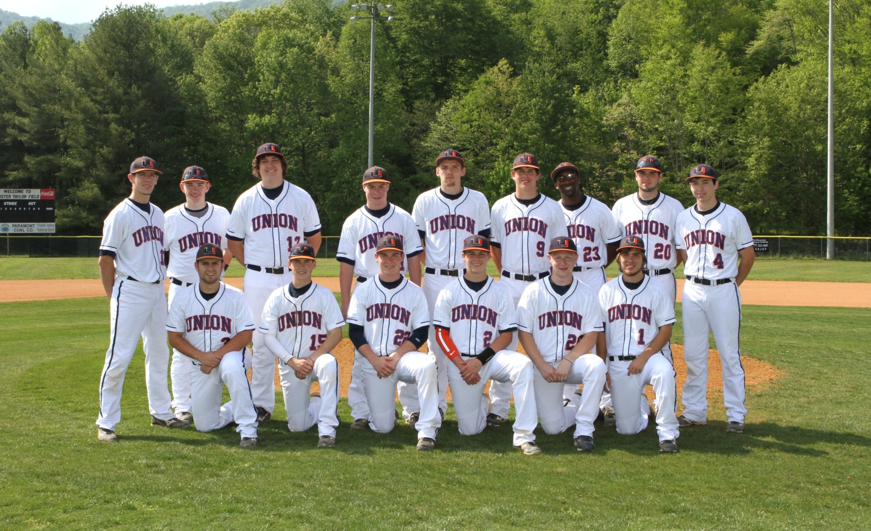
(Right click to save image)
Top Row: (L-R) Nathan Baker, Ethan Villiard, Codi Collins, Ben Baugh, Wes Hubbard,
Tanner Clark, Tyler Smith, Daniel Fawbush, Austin Baker
Bottom Row: (L-R) Steven Lane, Wyatt Hamilton, Jake Huff, Logan Dishner, Jessee Hagan, Ty Dean

