Page 1 of 5

2014 Union Bears Roster
Jersey | Player | Position | Year
1 | Braxton Back | IF | Fr.
2 | Tommy Fleenor | 2B/P | Jr.
3 | Ethan Sampson | OF | Sr.
4 | Cameron Fannon | C | Fr.
5 | Tanner Hall | OF | Jr.
6 | Logan Mullins | SS/P | Sr.
7 | Will Hubbard | SS/P | So.
9 | Zack Cornett | OF/P | Fr.
10 | Matt Ashley | OF | Jr.
14 | Ethan Villiard | OF | Jr.
15 | Bubba Hubbard | 1B/P | So.
17 | Trevor Horner | OF/P | Sr.
20 | Braxton Bishop | C/P | So.
21 | Robbie Gilliam | 1B/P | Jr.
22 | Tristan Grubb | OF | Jr.
23 | Hunter Neece | 1B/P | Sr.
26 | Stuart Barton | DH | Sr.
Varsity Head Coach |  | J.W. Salyers
Varsity Asst. Coach |  | Steve Hubbard Jr.
Varsity Asst. Coach |  | David Gregory
Varsity Asst. Coach |  | Todd Giles
Varsity Asst. Coach |  | Tommy Meier
JV Head Coach |  | John Dean
JV Asst. Coach |  | Tyler McFarland

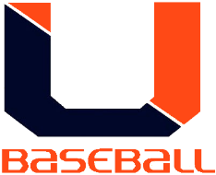

Page 2 of 5
2014 Final Statistics
Overall Record: 16 – 6
Hitting Statistics
Name | PA | AB | H | HR | XBH | RBI | BB | SO | SB | OBP | AVG | BA/RSP
Tristan Grubb | 5 | 4 | 2 | 0 | 0 | 2 | 1 | 1 | 3 | .600 | .500 | .500
Ethan Villiard | 87 | 66 | 31 | 3 | 13 | 21 | 22 | 8 | 7 | .598 | .470 | .500
Will Hubbard | 94 | 85 | 36 | 0 | 7 | 21 | 9 | 8 | 3 | .479 | .424 | .560
Hunter Neece | 85 | 76 | 29 | 1 | 4 | 29 | 8 | 9 | 3 | .412 | .382 | .439
Braxton Bishop | 70 | 60 | 22 | 0 | 2 | 14 | 9 | 11 | 5 | .443 | .367 | .269
Matt Ashley | 26 | 25 | 9 | 0 | 2 | 6 | 1 | 6 | 0 | .385 | .360 | .400
Ethan Sampson | 8 | 6 | 2 | 0 | 0 | 0 | 2 | 1 | 0 | .500 | .333 | .000
Tommy Fleenor | 88 | 76 | 25 | 0 | 3 | 10 | 6 | 9 | 8 | .369 | .329 | .370
Robbie Gilliam | 38 | 28 | 9 | 0 | 1 | 7 | 10 | 11 | 1 | .500 | .321 | .273
Stuart Barton | 47 | 37 | 11 | 1 | 4 | 10 | 10 | 12 | 0 | .447 | .297 | .333
Rhett Lunsford | 56 | 47 | 13 | 0 | 2 | 12 | 8 | 11 | 3 | .382 | .277 | .292
Tanner Hall | 73 | 55 | 14 | 0 | 0 | 8 | 16 | 14 | 8 | .423 | .255 | .217
Logan Mullins | 71 | 59 | 12 | 0 | 1 | 8 | 10 | 12 | 6 | .319 | .203 | .304
Bubba Hubbard | 29 | 23 | 3 | 1 | 1 | 4 | 7 | 9 | 1 | .310 | .130 | .077
Braxton Back | 1 | 1 | 0 | 0 | 0 | 0 | 0 | 0 | 2 | .000 | .000 | .000
Zack Cornett | 1 | 1 | 0 | 0 | 0 | 1 | 0 | 0 | 0 | .000 | .000 | .000
Cameron Fannon | 2 | 1 | 0 | 0 | 0 | 0 | 1 | 0 | 2 | .500 | .000 | .000
Trevor Horner | 2 | 1 | 0 | 0 | 0 | 0 | 1 | 0 | 0 | .500 | .000 | .000
TOTALS | 783 | 651 | 218 | 6 | 40 | 153 | 121 | 122 | 52 | .433 | .335 | .354

Pitching Statistics
Name | W | L | SV | IP | ERA | K | H | BB | BAA
Trevor Horner | 0 | 0 | 0 | 0.1 | 0.00 | 1 | 0 | 0 | .000
Will Hubbard | 7 | 2 | 0 | 60.2 | 1.62 | 74 | 49 | 15 | .212
Tommy Fleenor | 5 | 0 | 0 | 30.2 | 2.05 | 26 | 22 | 16 | .188
Bubba Hubbard | 1 | 0 | 0 | 5.2 | 2.47 | 8 | 5 | 7 | .238
Hunter Neece | 0 | 2 | 3 | 18.0 | 3.11 | 29 | 19 | 8 | .268
Braxton Bishop | 0 | 1 | 0 | 7.0 | 4.00 | 1 | 7 | 3 | .259
Rhett Lunsford | 1 | 0 | 0 | 3.0 | 4.67 | 2 | 3 | 4 | .25
Logan Mullins | 2 | 1 | 1 | 23.2 | 4.73 | 28 | 26 | 21 | .265
Robbie Gilliam | 0 | 0 | 0 | 5.0 | 7.00 | 6 | 10 | 5 | .435
Tanner Hall | 0 | 0 | 0 | 1.0 | 7.00 | 1 | 1 | 3 | .250
TOTALS | 16 | 6 | 4 | 155.0 | 2.75 | 176 | 142 | 82 | .235

Page 3 of 5

2014 Schedule and Results
Opponent | Location | Result
Letcher Co., KY | Home | Win
Castlewood | Away | Win
Lebanon | Home | Win
JI Burton | Away | Win
David Crockett | Away | Win
Pike Central, KY | Away | Win
Sullivan North | Home | Win
Lee High | Home | Win
Tazewell | Home | Win
Central – Wise | Away | Loss
John Battle | Home | Loss
Gate City | Away | Win
JI Burton | Home | Win
Castlewood | Home | Win
Lee High | Away | Win
Central – Wise | Home | Loss
John Battle | Away | Loss
Gate City | Home | Win
Virginia High | Home | Loss
Abingdon | Away | Win
Clinch Mountain Conference Tournament
Lebanon | Virginia High | Win
Virginia High | Virginia High | Loss
Totals |  | 16 - 6

Page 4 of 5

2014 began Union High School’s first year in a new District, Conference, and Region. The Bears were placed into the Mountain District, Clinch Mountain Conference (40), and Region 2A West for athletic competition. Our baseball team had a solid season accumulating 16 wins in 22 games. The team was led by Seniors Ethan Sampson, Trevor Horner, Logan Mullins, Hunter Neece, and Stuart Barton.
The 2014 season will be best remembered by Union’s 4-3 win over Lebanon in the Conference Tournament. The Bears outlasted Lebanon in 15 innings to capture the win. Other highlights from the season included two 7th inning come from behind road wins at David Crockett and Abingdon. The 2014 Bears started the season out 9-0 and continued to improve as the season progressed. The season came to an end in the Conference Tournament with a 6-0 semifinal loss to a very good Virginia High team.
Personal Achievements for 2014
Player | Achievement
Ethan Villiard | 1st Team All-Conference OF
Will Hubbard | 1st Team All-Conference Pitcher  1st Team All-Conference SS
Hunter Neece | 2nd Team All-Conference 1B

Page 5 of 5

2014 Team Photo

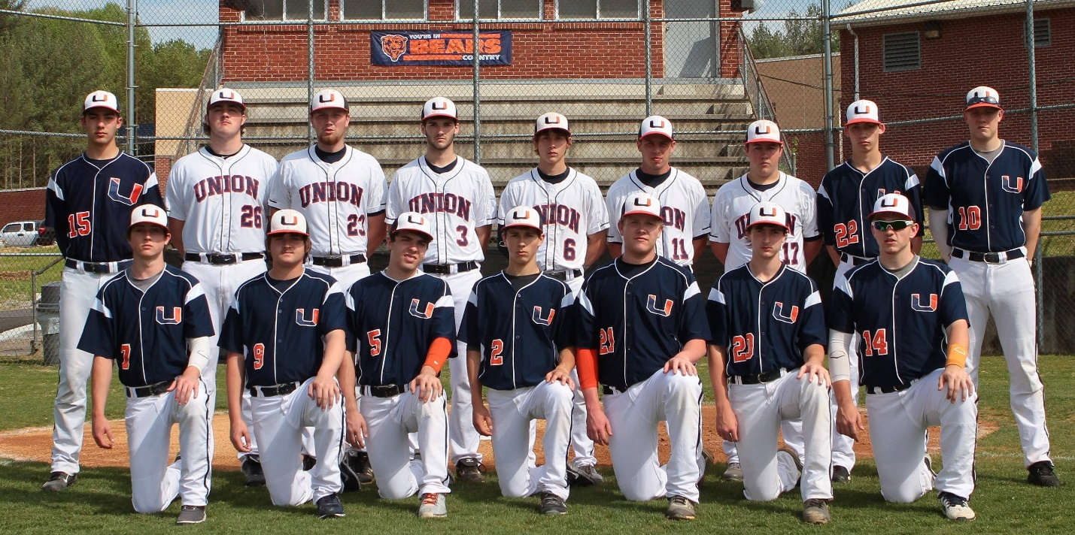

Standing (L-R): Bubba Hubbard, Stuart Barton, Hunter Neece, Ethan Sampson, Logan Mullins,
Rhett Lunsford, Trevor Horner, Tristan Grubb, Matt Ashley

Kneeling (L-R): Will Hubbard, Zack Cornett, Tanner Hall, Tommy Fleenor, Robbie Gilliam,
Braxton Bishop, Ethan Villiard

