Page 1 of 5

2015 Union Bears Roster
Jersey | Player | Position | Year
1 | Braxton Back | IF | So.
2 | Tommy Fleenor | 2B/P | Jr.
3 | Blake Patrick | OF | Jr.
4 | Zack James | P/OF | Fr.
5 | Tanner Hall | OF | Sr.
6 | Cameron Fannon | IF/C | So.
7 | Will Hubbard | SS/P | Jr.
9 | Zack Cornett | OF/P | So.
10 | Matt Ashley | OF | Sr.
11 | Justin Clark | 3B/2B | So.
12 | Braxton Zirkle | 2B | Fr.
14 | Ethan Villiard | OF/C | Sr.
15 | Bubba Hubbard | 1B/P | Jr.
20 | Braxton Bishop | C/P | Jr.
21 | Robbie Gilliam | 1B/P | Sr.
22 | Tristan Grubb | OF | Sr.
23 | Drew Burke | P/OF | So.
Varsity Head Coach |  | J.W. Salyers
Varsity Asst. Coach |  | Steve Hubbard Jr.
Varsity Asst. Coach |  | David Gregory
Varsity Asst. Coach |  | Josh Blackburn
Varsity Asst. Coach |  | Tyler McFarland
JV Head Coach |  | Tim Baker
JV Asst. Coach |  | Ty King

Page 2 of 5
2015 Final Statistics
Overall Record: 13 – 8
Hitting Statistics
Hitter | PA | AB | R | H | XBH | HR | RBI | AVG | BB | SO | SB | OBP | BA/RISP
Villiard | 80 | 64 | 24 | 32 | 9 | 4 | 24 | .500 | 14 | 8 | 8 | .575 | .457
W. Hubbard | 84 | 68 | 21 | 24 | 9 | 0 | 16 | .353 | 16 | 8 | 7 | .476 | .483
James | 13 | 12 | 2 | 4 | 0 | 0 | 2 | .333 | 1 | 1 | 1 | .385 | .200
B. Hubbard | 74 | 53 | 12 | 17 | 6 | 3 | 22 | .321 | 21 | 16 | 1 | .514 | .333
Grubb | 60 | 43 | 16 | 12 | 2 | 0 | 10 | .279 | 12 | 13 | 4 | .436 | .353
Fleenor | 79 | 69 | 15 | 19 | 6 | 1 | 14 | .275 | 9 | 9 | 8 | .359 | .350
Hall | 60 | 44 | 10 | 11 | 3 | 0 | 13 | .250 | 14 | 12 | 5 | .431 | .278
Clark | 25 | 18 | 7 | 4 | 1 | 0 | 3 | .222 | 6 | 9 | 4 | .417 | .143
Back | 51 | 38 | 15 | 8 | 1 | 0 | 5 | .211 | 10 | 14 | 6 | .375 | .308
Gilliam | 68 | 57 | 4 | 12 | 1 | 0 | 10 | .211 | 8 | 16 | 0 | .294 | .231
Cornett | 18 | 16 | 5 | 3 | 1 | 0 | 2 | .188 | 1 | 8 | 0 | .235 | .143
Zirkle | 23 | 12 | 10 | 2 | 0 | 0 | 2 | .167 | 10 | 5 | 7 | .522 | .200
Bishop | 46 | 39 | 0 | 5 | 0 | 0 | 5 | .128 | 6 | 15 | 1 | .239 | .188
Ashley | 21 | 17 | 6 | 2 | 0 | 0 | 3 | .118 | 4 | 6 | 0 | .286 | .111
Patrick | 3 | 2 | 2 | 0 | 0 | 0 | 0 | .000 | 1 | 2 | 0 | .333 | .000
Fannon | 5 | 3 | 11 | 0 | 0 | 0 | 1 | .000 | 2 | 1 | 5 | .400 | .000
Team Totals | 710 | 555 | 160 | 155 | 38 | 8 | 132 | .279 | 135 | 143 | 57 | .416 | .318

Pitching Statistics
Pitcher | G | W | L | SV | IP | ER | ERA | K | H | BB | WHIP | BAA
W. Hubbard | 10 | 4 | 3 | 2 | 44.2 | 5 | 0.81 | 48 | 29 | 23 | 1.08 | .180
Bishop | 6 | 1 | 0 | 0 | 13.2 | 5 | 2.56 | 11 | 8 | 9 | 1.02 | .151
Fleenor | 12 | 2 | 4 | 1 | 31.1 | 17 | 3.89 | 47 | 29 | 28 | 1.60 | .232
B. Hubbard | 11 | 3 | 1 | 0 | 25.0 | 20 | 5.60 | 35 | 17 | 26 | 1.44 | .181
James | 8 | 3 | 0 | 0 | 17.2 | 20 | 8.21 | 17 | 23 | 25 | 2.27 | .329
Hall | 1 | 0 | 0 | 0 | 1.2 | 3 | 12.60 | 2 | 4 | 2 | 3.60 | .400
Gilliam | 1 | 0 | 0 | 0 | 1.0 | 8 | 56.00 | 1 | 6 | 3 | 9.00 | .750
Team Totals | 21 | 13 | 8 | 3 | 135.0 | 78 | 4.12 | 161 | 116 | 116 | 1.50 | .223

Page 3 of 5

2015 Schedule and Results
Opponent | Location | Result
Sullivan South | Away | Loss
Castlewood | Away | Win
Sullivan North | Away | Win
Lebanon | Away | Loss
Castlewood | UVA-Wise | Win
JI Burton | Away | Win
Pike Central, KY | UVA-Wise | Win
John Battle | Away | Win
Lee High | Away | Win
Central – Wise | Home | Loss
JI Burton | Home | Win
Gate City | Away | Win
John Battle | Home | Win
Virginia High | Home | Loss
Lee High | Home | Win
Central – Wise | Away | Loss
Gate City | Home | Win
Lebanon | Home | Loss
Abingdon | Home | Loss
Clinch Mountain Conference Tournament
Gate City | Home | Win
Lebanon | Virginia High | Loss
Totals |  | 13 - 8

Page 4 of 5

2015 was a season of ups and downs for the Bears. Likely the most memorable part of the season was playing the first 9 games away from Buster Taylor Field. A drainage system was installed in the outfield prior to the 2015 season and prevented home games from being played until late April. The 2015 team was highly competitive within the Clinch Mountain Conference. The Bears saw their share of 1 run wins and also their share of 1 run losses. The Bears finished in a 3 way tie for third place in the conference with John Battle and Central.
The 2015 season was the final year for 6 Union Seniors. This was the first class to enter high school under the name Union. Several Seniors left their mark on the program and will be missed for years to come.
Personal Achievements for 2015
Player | Achievement
Ethan Villiard | 1st Team All-Conference OF
Will Hubbard | 1st Team All-Conference SS  2nd Team All-Conference P
Bubba Hubbard | 2nd Team All-Conference 1B  2nd Team All-Conference DH
Tommy Fleenor | Honorable Mention All-Conference 2B

Page 5 of 5

2015 Team Photo

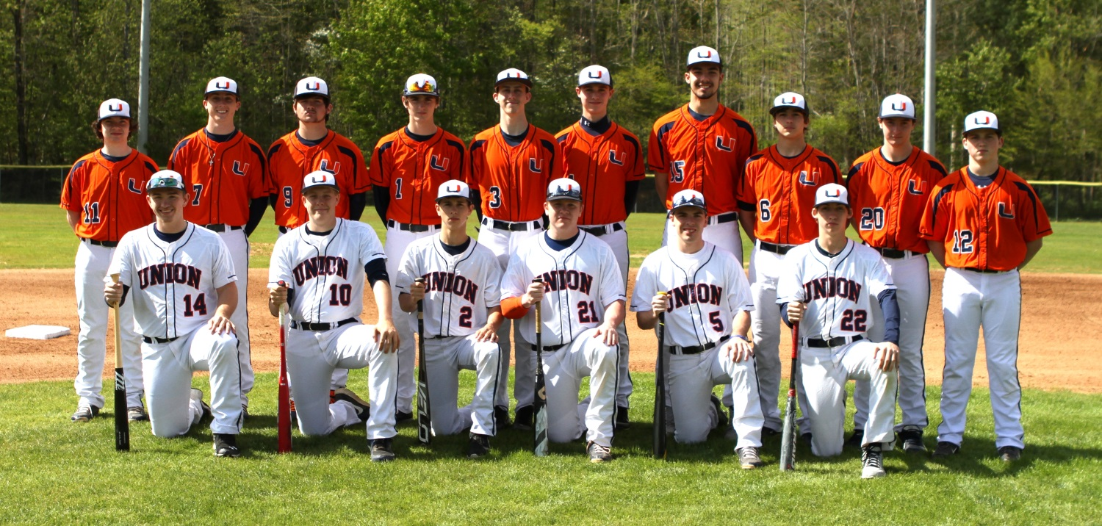

Standing (L-R): Justin Clark, Will Hubbard, Zack Cornett, Braxton Back, Blake Patrick,
Zack James, Bubba Hubbard, Cam Fannon, Braxton Bishop, Braxton Zirkle

Kneeling (L-R): Ethan Villiard, Matt Ashley, Tommy Fleenor, Robbie Gilliam,
Tanner Hall, Tristan Grubb

